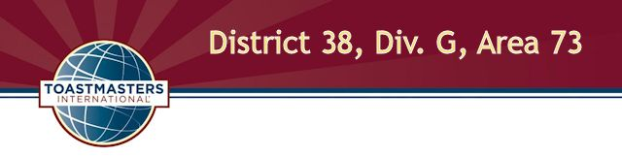
International Speech and Evaluation Contest
Saturday, March 12, 2016
11:00 A.M. at Horsham Township Library

Agenda

Contest Chair Title, Name, TM credentials
Chief Judge Name, TM credentials
Evaluation Contest Test Speaker Name, TM credentials

11:00 Opening
Contest chair greets attendees and announces period for contestants to prepare and submit necessary paperwork.

11:30 Briefings
Contest chair briefs contestants and has them draw for speaking positions. Chief judge briefs judges, ballot counters and timers.

11:50 Call to order
Sergeant at arms calls the contest to order and introduces the contest chair.

11:51 Welcome
Contest chair welcomes contestants, functionaries, dignitaries and guests.

11:52 International Speech Contest (5-7 min. per speaker, 1 min. between each speech)

Contestant name Speech title Order

List in alpha order title _____
List in alpha order title _____

12:01 Between-contest break (15 min.)

12:16 Call to order
Sergeant at arms reconvenes the contest and introduces the contest chair.

12:17 Evaluation Contest Test Speech
Title (5-7 min.)

12:24 Contestant evaluation preparation time
Contest chair interviews the test speaker.

12:29 Evaluation Contest: (2-3 min. per speaker, 1 min. between each speech)

Contestant name Order

List in alpha order _____
List in alpha order _____

12:48 Contestant Interviews (3 min. each)
Contest chair interviews contestants.

12:57 Contest Winner Announcements
Contest chair announces contest winners.

13:02 Closing
Contest chair shares closing comments. Area and division governors share comments.

13:07 Adjournment

The contest organizers wish to thank our generous sponsors for providing the food for today's contest; we ask that in appreciation you give them your business.

Tony Roni's, Willow Grove
The Fresh Market, Welsh Road, Horsham

